New York University

Database Systems - CSCI-GA.2433-001
Ronojoy Mitra

Database Systems Project Part II – Logical Schema Optimization and Unstructured Data Collection

I - Introduction
- This report covers part 2 of the Database Systems project. For part 2 the choice was made to stick with the insurance company idea from part 1. The business goal of the project is aligned with the initial idea of insurance companies forecasting chronic disease risk to inform insurance rates. In this case it is helping the insurer forecast chronic disease risk using factors such as social vulnerability, health behaviour and environmental condition. The hope being that the insight eventually derived from this project can serve the insurance company to inform insurance rates and product insights for the company.

II - Logical Schema
- The logical schema is implemented in PostgreSQL 16 in a database titled ‘insurancecomp2_eda’ and exists in a dedicated schema titled ‘eda.’ There was a significant effort placed in streamlining and consolidating the ~80 entities from part 1’s conceptual model that existed across seven subject areas into ~25 entities that are relevant to the goal of forecasting chronic disease risk. The changes, additions and omissions from the part 1 conceptual model is listed below.

  - Changes
    - Conceptual model name: Account-h
eda schema name: account
Changes made: Account-h was consolidated and the 8 column natural key was replaced with a surrogate key called account_id.

- Conceptual model name: Customer
eda schema name: member
Changes made: Customer was renamed to member as member serves a more accurate description of customer since an entity could be the paying customer of the account with multiple members from the entity as members. The 5 column natural key was replaced with a surrogate key called member_id.

- Conceptual model name: Contract-h/ LifePolicy/ AHPolicy/ FLEXAgreement
eda schema name: contract
Changes made: The subtype hierarchy was flattened with the line of business now being carried via the product/plan

- Conceptual model name: Product-h/ ProductSeries-h/ ProductPlan-h/ ProductRider-h
eda schema name: product/ product_plan/ product_rider
Changes made: the 4 level hierarchy was compressed to 3.

- Conceptual model name: Claim/ ClaimNote/ Coverage_Claim/ Claimant-Participant
eda schema name: claim/ claim_line/ claim_diagnosis
Changes made: Restructured around diagnosis_code and claim_line.

- Conceptual model name: ContractBenefit/ ContractPremium
eda schema name: contract_benefit/ contract_premium
Changes made: Kept largely the same except was contract_premium has premium_id as a surrogate key since contract_id,rider_id is not unique on its own.
- Additions
    - eda schema name: state/ county/ zip_code
Reasoning: These were added as geographic reference data for the hybrid extension

- eda schema name: diagnosis_code/ chronic_condition/ clinical_observation/ geo_health_indicator
Reasoning: These were added as structured chronic disease signals tables

- eda schema name: data_source_catalog/ unstructured_asset
Reasoning: These were added as the data lake metadata and the raw asset bridge.

- eda schema name: provider
Reasoning: Added to carry claims-level provider context that would be needed for claim and chronic condition analysis

- Omissions
    - Conceptual model name: Associate-h, ManagerContract, SitCode chain, Territory/Region/District, BillingAccount-h, Invoice, InvoiceDetail, Remittance, Contest, Assoc_Contest, District/Regional/State coordinators
Reasoning: Sales-operations hierarchy, Billing subject area and sales incentive subject area were all omitted in favour of a more streamlined and focused implementation of the project.

III - Optimization and Hybrid Data Extension
- There was a single rule that was applied across every single entity that was brought over from part 1, where any entity whose conceptual model primary key was a composite of three or more natural language columns and which cascaded as a multi column foreign key into each child and junction table was assigned a single column surrogate key. This was done while still preserving the original natural key columns as a Unique constraint on the parent table so as to preserve the information while preventing it from propagating down the hierarchy. Although for pure junction tables like contract_benefit the rule was applied indirectly as both referenced parent entities had surrogate keys applied to them so the junction tables composite key collapsed into two surrogate referencing columns.

The optimization reduces both storage overheads and also the join costs as the large natural key columns no longer repeat down the hierarchy. It does this while keeping the constraints still present allowing previous logic to still hold.

Extending the schema to inter relate structured and unstructured data was done using a three layered pattern where
- data_source_catalog is a registry of each external dataset containing: name, source URL, publisher, license, data lake zone and path, grain, refresh cadence, row count, contains_phi flag and quality_status.
- staging tables, one per source file holds each dataset at its native grain as downloaded/obtained matching the source file column for column.
- geo_health_indicator is the curated and structured table holding one row per county per indicator per year that analytics and reporting would actually query.

The pattern being a bronze to curated one has raw files being preserved at their native grain in the staging/raw layer and an aggregation step producing the county level rows that are loaded into geo_health_indicator which is the finest grain the schema’s geographic data supports. A companion table called unstructured_asset also exists to register raw files and link them when relevant back to member/claim/contract records.

IV - Data Lake
- Three datasets were used to construct the data lake. These were public tract or county level datasets selected to help represent the social, behavioral and environmental factors that would be useful in forecasting chronic diseases. All three chosen datasets are at a population/geographic level to avoid using Protected Health Information of individuals. The datasets are as follows
  - Dataset: CDC Social Vulnerability Index (SVI)-NY
Native Grain: Census tract
Key Measures: Overall social vulnerability percentile

  - Dataset: CDC PLACES - Local Data for Better Health (2025)
Native Grain: Census tract
Key Measures: Diabetes, coronary heart disease, stroke, COPD, cancer, smoking .etc

  - Dataset: EPA Annual AQI by County (2025)
Native Grain: County
Key Measures: Median AQI, count of unhealthy air quality days .etc

V - Insights to the EDA and Reference Architecture
- Once the datasets reach geo_health_indicator it is keyed by county_id which is the same geographic reference data that account can reach through its zip_id and that members reach through their associated member_address record. Thus a member’s or account’s county can be joined directly to the county-level, social-vulnerability, chronic-disease-prevalence, and air-quality indicators. In the EDA model this could join with other paths such as Marketing and Sales that could help incorporate county level risk context alongside existing account and contract data.

- The reference architecture that would support the hybrid model would have 5 layers, wrapped in a governance layer since the project has the potential to deal with personal health data going forward that would be under the protections of PHI. The business domain is the chronic-disease forecasting goal while the application domain is the PostgreSQL logical schema and the aggregation step, the DIKW domain is through the data_source_catalog’s metadata and geo_health_indicator’s curated indicators and the infrastructure domain is the cloud data lake and DB platform.
The layers of the reference architecture would be
  - Layer: Sources
Content: Currently 3 datasets (SVI, PLACES, AQI) at native grain
Where: Stored in CSVs

- Layer: Data lake - Bronze
Content: Raw files that are unmodified and catalogued by the grain/license/source
Where: MongoDB Atlas

- Layer: Data lake - Curated
Content: County level aggregation
Where: Staging tables to geo_health_indicator

- Layer: Logical Schema
Content: Normalized eda schema: account/member/contract/claim core and hybrid extension
Where: PostgreSQL 16

- Layer: Analytics
Content: Insights, Marketing, Reporting
Where: ODS/BI Warehouse

  - Layer: Governance
Content: wraps all layers and has contains_phi flag, quality_status, source licensing
Where: data_source_catalog/ unstructured_asset metadata

VI - Cloud Implementation
- The PostgreSQL database was deployed and populated locally while the three source datasets are stored in MongoDB Atlas losslessly. MongoDB Atlas was used as the platform for the raw/bronze layer of the hybrid architecture due to its free plan(up to 500MB). The bronze database contains three collections, one per source dataset.

VII - Screenshots
- Below are screenshots from the implementation of the project

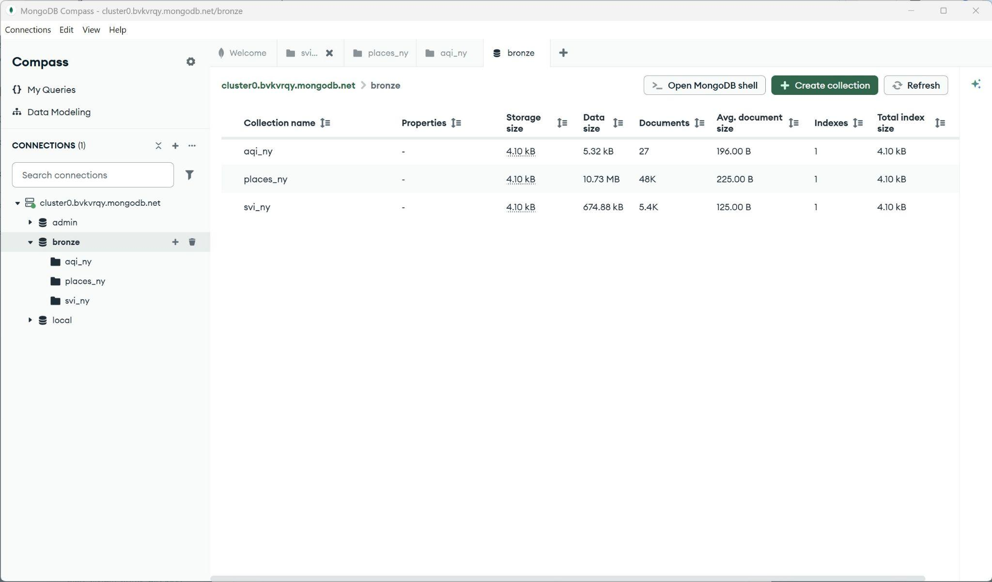

Figure: Datasets stored in the MongoDB Atlas Cloud storage.

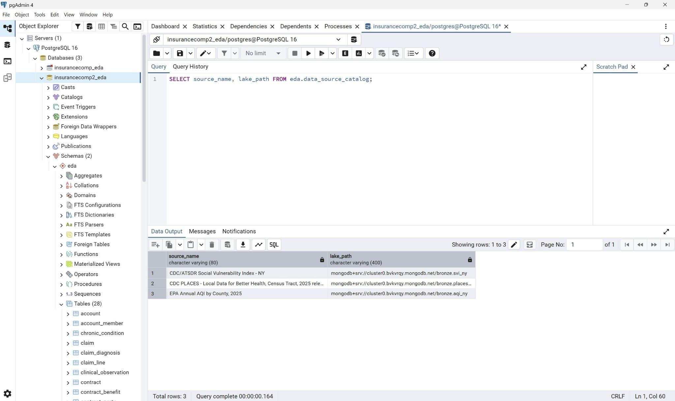

Figure: Query being made from pgAdmin

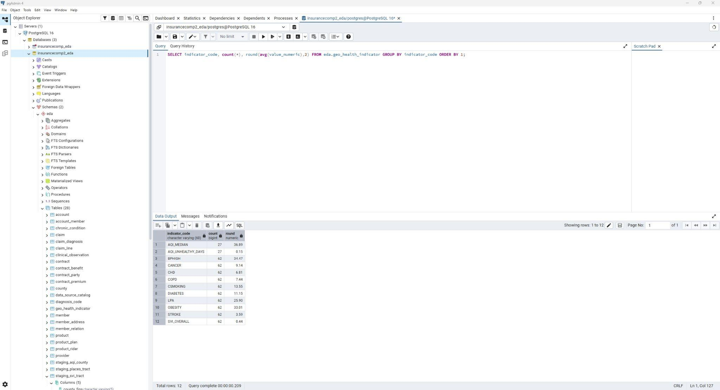
Figure: geo_health_indicator query
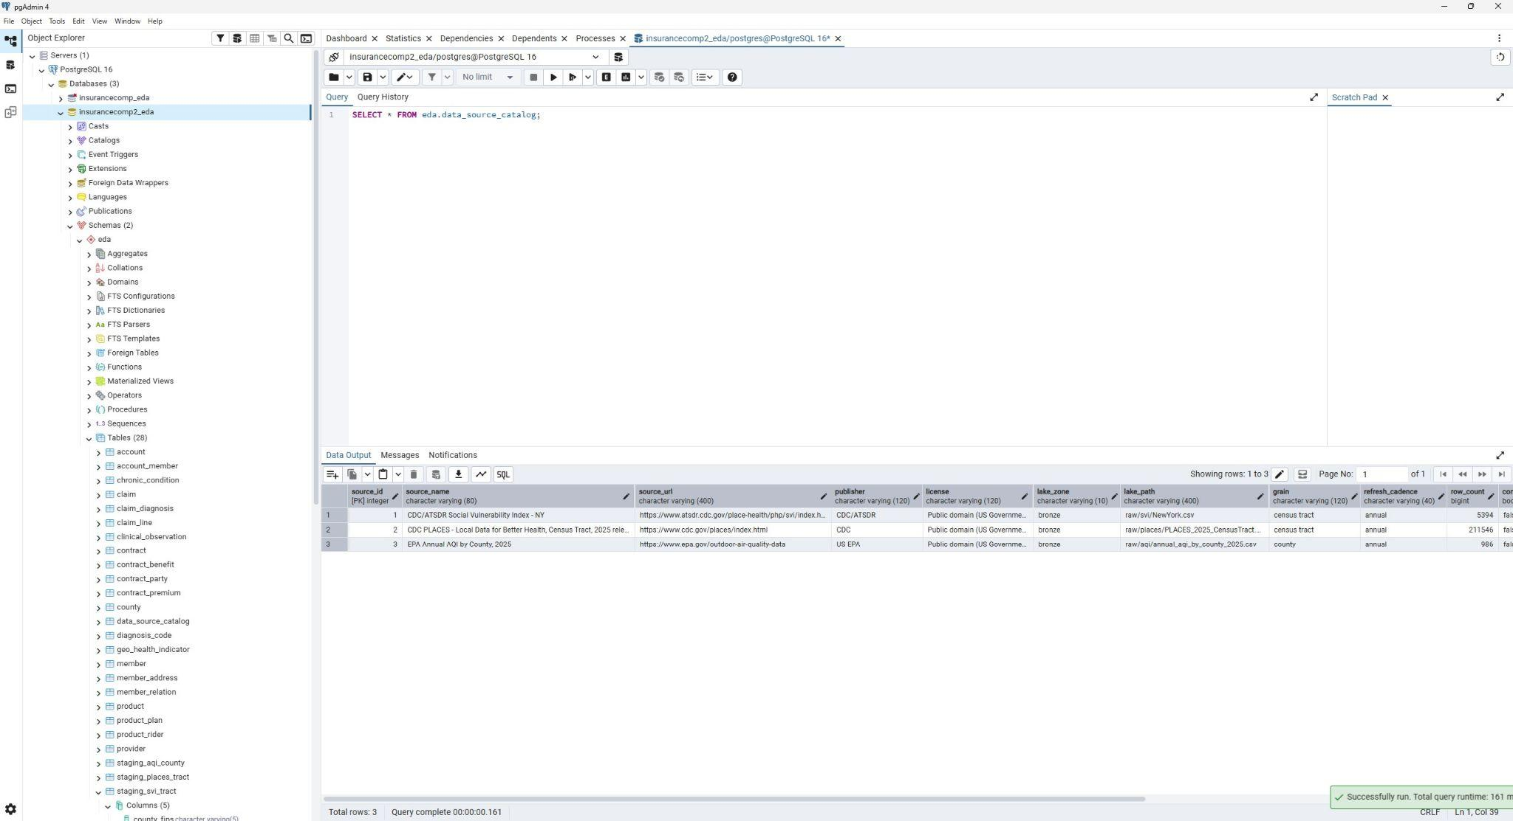
Figure: data_source_catalog query

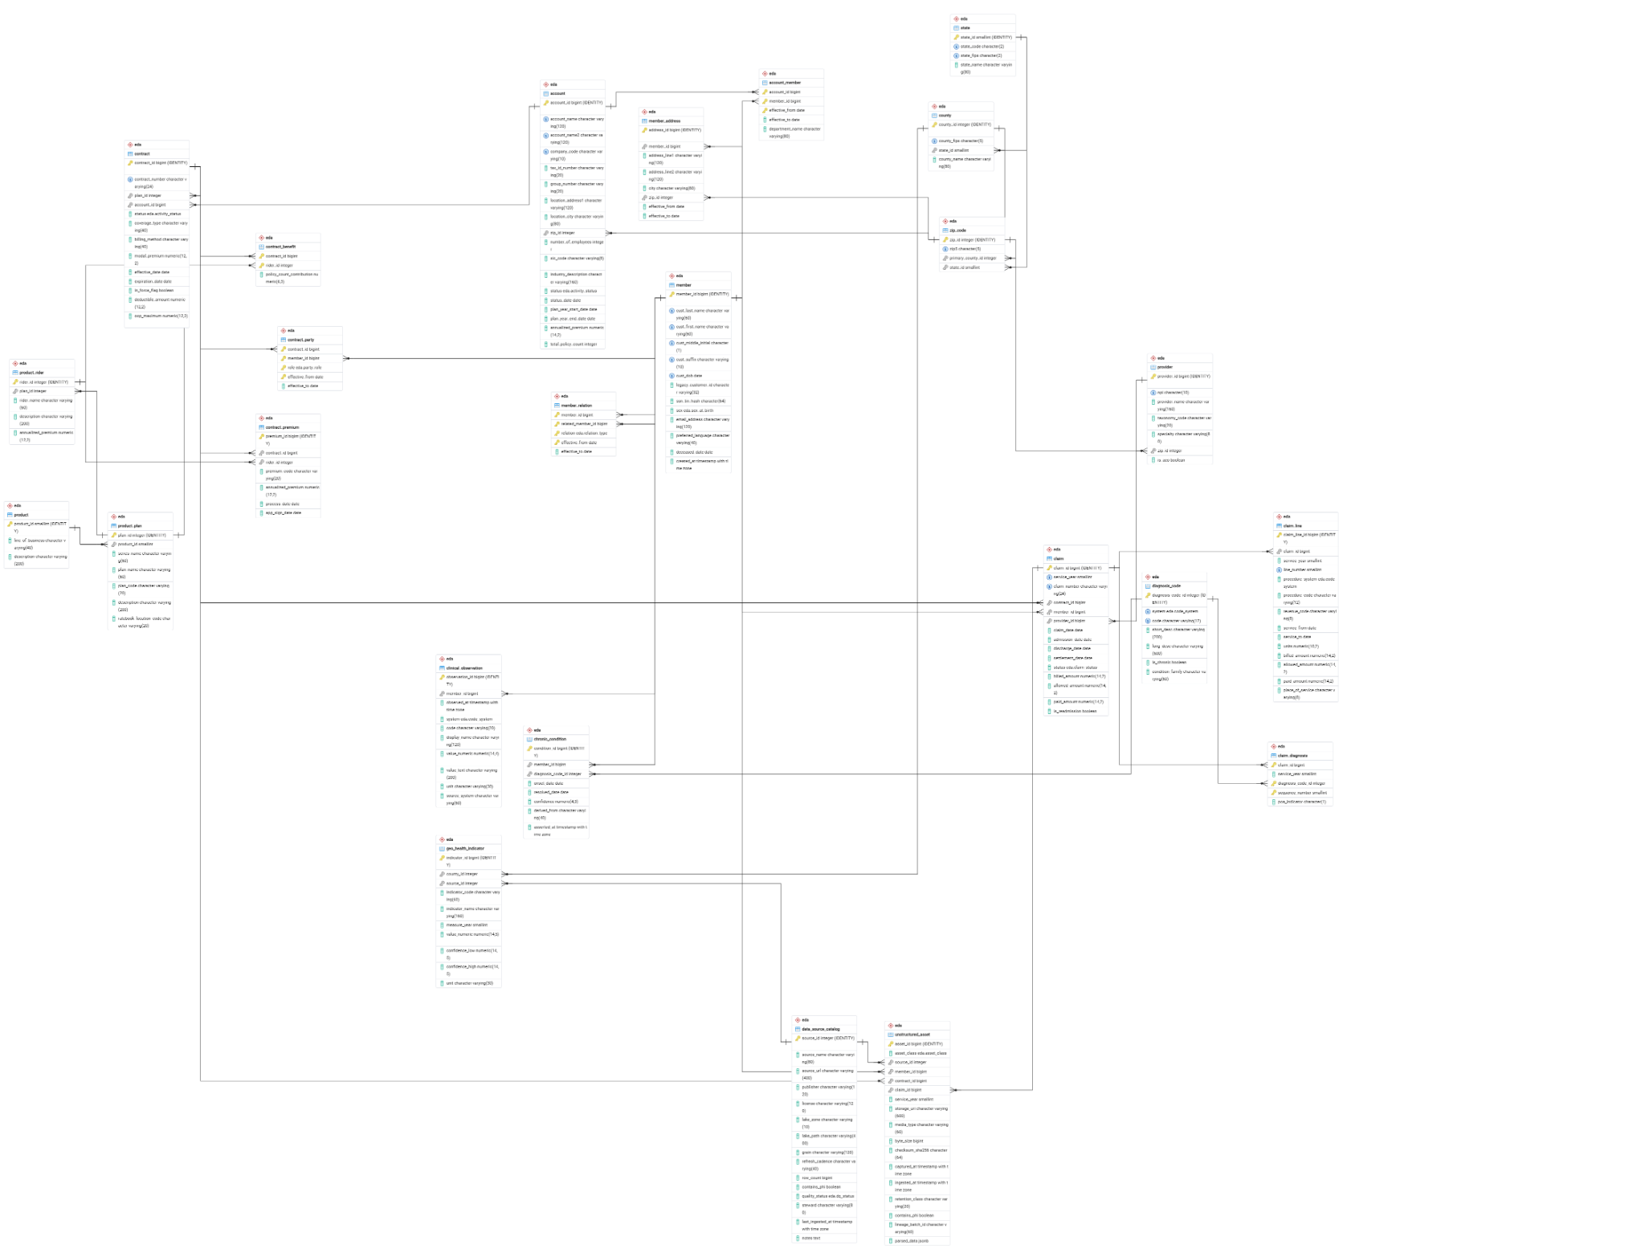
Figure: ERD Diagram(Hi res image in submission)

VIII - Conclusion
- This part of the project created an optimized surrogate keyed logical schema on PostgreSQL while applying optimization rules and refining the focus of the schema. The schema was supported by three real public datasets that were sourced, curated to assist in the business goal of better forecasting chronic disease risk and was stored in MongoDB Atlas.

